The effect of dissolved salt on the boiling point of water

Aims
- To measure if dissolving salt in water affects its boiling point.
- To measure if dissolving salt in water changes the rate at which the salt/water mixture heats up.

Hypothesis
- __________________________________________________________________________________________________________________________________________________________________
- __________________________________________________________________________________________________________________________________________________________________
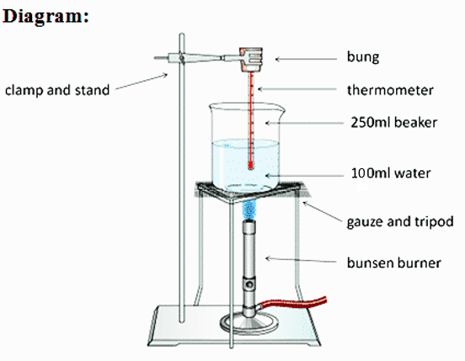
Apparatus

Stopwatch
Bunsen burner
Tripod
Gauze mat
Heat mat (for bench)
250mL Beaker
100mL Measuring cylinder
Electronic balance
Stand and clamp
Distilled water bottle
Spatula
Salt
Rubber bung
Stirring rod

Method
- Place the beaker on the electronic balance and “zero” it. Use the spatula to place 6 grams of salt into the beaker.
- Use the measuring cylinder to add 100mL of water to the beaker. Stir until the salt has dissolved.
- Carefully arrange the equipment like the diagram above – except the Bunsen should be unlit.
- Check that the bulb of the thermometer is completely surrounded by water and not touching the bottom of the beaker. Take the Bunsen burner out from under the tripod.
- Record the temperature of the water in the table below.
- Light the Bunsen and set it to a blue flame. Place it under the tripod and start your timer.
- Record the temperature every 1 minute. Keep recording until the temperature remains the same (about the same – approximately 1⁰C difference) for two consecutive minutes. The salt/water mixture should be boiling by 10 minutes. If not continue heating until it boils. Stop the Bunsen burner.
Alternatively, four groups can do different concentrations of salt and share results. Much quicker… but is it as accurate?
- Repeat steps 1 – 7 using an additional 6 g of salt (Change step 1 slightly).
- Repeat step 8 two more times.

Risk Assessment:
Source of risk | What amount of harm could it cause? (circle) | Safety precautions taken | If an incident occurred what should I do?
 | Minor / Significant / major
 | Minor / Significant / major
Results:
Table 1: The effect of concentration of salt on the heating and the boiling of water.

Mass of salt in water  (g) | Time  (minutes) | Temperature of salt/water  (⁰C) |  | Mass of salt in water  (g) | Time  (minutes) | Temperature of salt/water  (⁰C)
 | 0 |  |  |  | 0
 | 1 |  |  |  | 1
 | 2 |  |  |  | 2
 | 3 |  |  |  | 3
 | 4 |  |  |  | 4
 | 5 |  |  |  | 5
 | 6 |  |  |  | 6
 | 7 |  |  |  | 7
 | 8 |  |  |  | 8
 | 9 |  |  |  | 9
 | 10 |  |  |  | 10
Mass of salt in water  (g) | Time  (minutes) | Temperature of salt/water  (⁰C) |  | Mass of salt in water  (g) | Time  (minutes) | Temperature of salt/water  (⁰C)
 | 0 |  |  |  | 0
 | 1 |  |  |  | 1
 | 2 |  |  |  | 2
 | 3 |  |  |  | 3
 | 4 |  |  |  | 4
 | 5 |  |  |  | 5
 | 6 |  |  |  | 6
 | 7 |  |  |  | 7
 | 8 |  |  |  | 8
 | 9 |  |  |  | 9
 | 10 |  |  |  | 10

Graph 1: Temperature versus time for salt/water mix

Time (minutes)
Temperature (⁰C)
Key:

= ___ salt concentration

= ___ salt concentration

= ___ salt concentration

Analysis:
(First paragraph is about the first aim – reread it first – then try to complete the missing parts of the paragraph below)
The _______________________ dissolved in the water did / didn’t affect the boiling point of the water. As the _______________________ increased the boiling point of the water increased / decreased / remained the same. When ______ g of salt was dissolved in the water the boiling point was _____ ⁰C. When the ______ g of salt was dissolved in the water the boiling point was _____ ⁰C. This data shows how the boiling point _______________________ when the mass of salt dissolved in the water was increased.
(Second paragraph is about the second aim – reread it first – then try to complete the missing parts of the paragraph below)
The _______________________ dissolved in the water did / didn’t affect the rate at which the water heated up. As the _______________________ increased the water heated up faster / slower / the same rate. When ______ g of salt was dissolved in the water, the water heated up at a rate of _____ ⁰C per minute. When ______ g of salt was dissolved in the water, the water heated up at a rate of _____ ⁰C per minute. This data shows how the rate at which the water heated _______________________ when the mass of salt dissolved in the water was increased.
(Third paragraph is about errors – the first sentence is easy, but then you have to list the errors and how you would fix them if you were to do the experiment again.)
There were no / few / significant / many errors in this experiment. The most important error was __________ ______________________________________________________________________________________. Another error was _______________________________________________________________________ ______________________________________________. These errors could be avoided if we _________ ____________________________________________________________________________________________________________________________________________________________________________.

Conclusion:

Write the first sentence of the first paragraph of your analysis. Write another sentence stating if this result agrees with your first hypothesis (see page 1). If your results does not agree with your hypothesis explain why (clue – two options – firstly there were errors in your experiment or there were no errors and your hypothesis was incorrect).  Write the first sentence of the second paragraph of your analysis. Write another sentence stating if this result agrees with your second hypothesis (see page 1). If your results does not agree with your hypothesis explain why (clue – two options – firstly there were errors in your experiment or there were no errors and your hypothesis was incorrect).  Write a sentence stating if the results of the experiment are valid (this depends on the amount of error. No or not much error means your reults are valid). Write one or two sentences about how this experiment could be improved if you were to do it again. | __________________________________________________________________________________________________________________________________________________________________________________________________________________________________________________________________________________________________________________________________________________________________________________________  __________________________________________________________________________________________________________________________________________________________________________________________________________________________________________________________________________________________________________________________________________________________________________________________  _______________________________________________________________________________________________________________________________________________________________________________________________________________________________________________________________________________________________________________________________________________________________________________________________________________________________________________________________________________________________________________________________________________________________________________________

